**TEST REPORT – 21.10.2023** [**https://www.pothys.com/**](https://www.pothys.com/)

1, Sort option in new arrivals is working in mobile web but it is not working desktop web & iPad web. Although the default sort for new arrivals is newest first. Either disable the Sort option in all mediums for new arrivals or fix it in desktop & iPad web.

**Mobile:**

**All types of sorts are working**

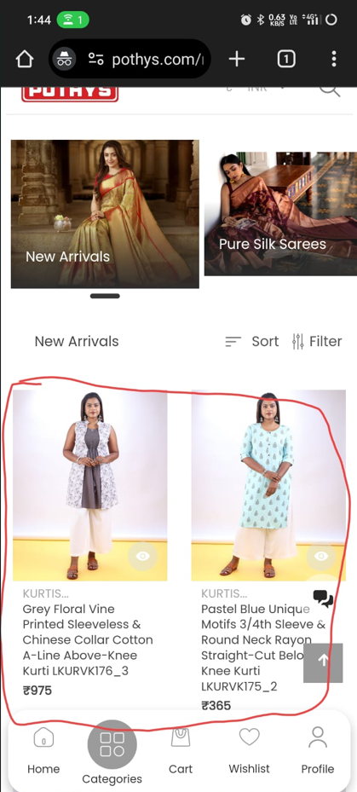

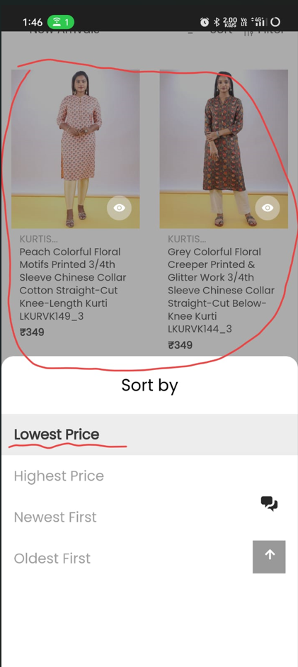

**Desktop:**

**Sort not changing stays on newest first…**

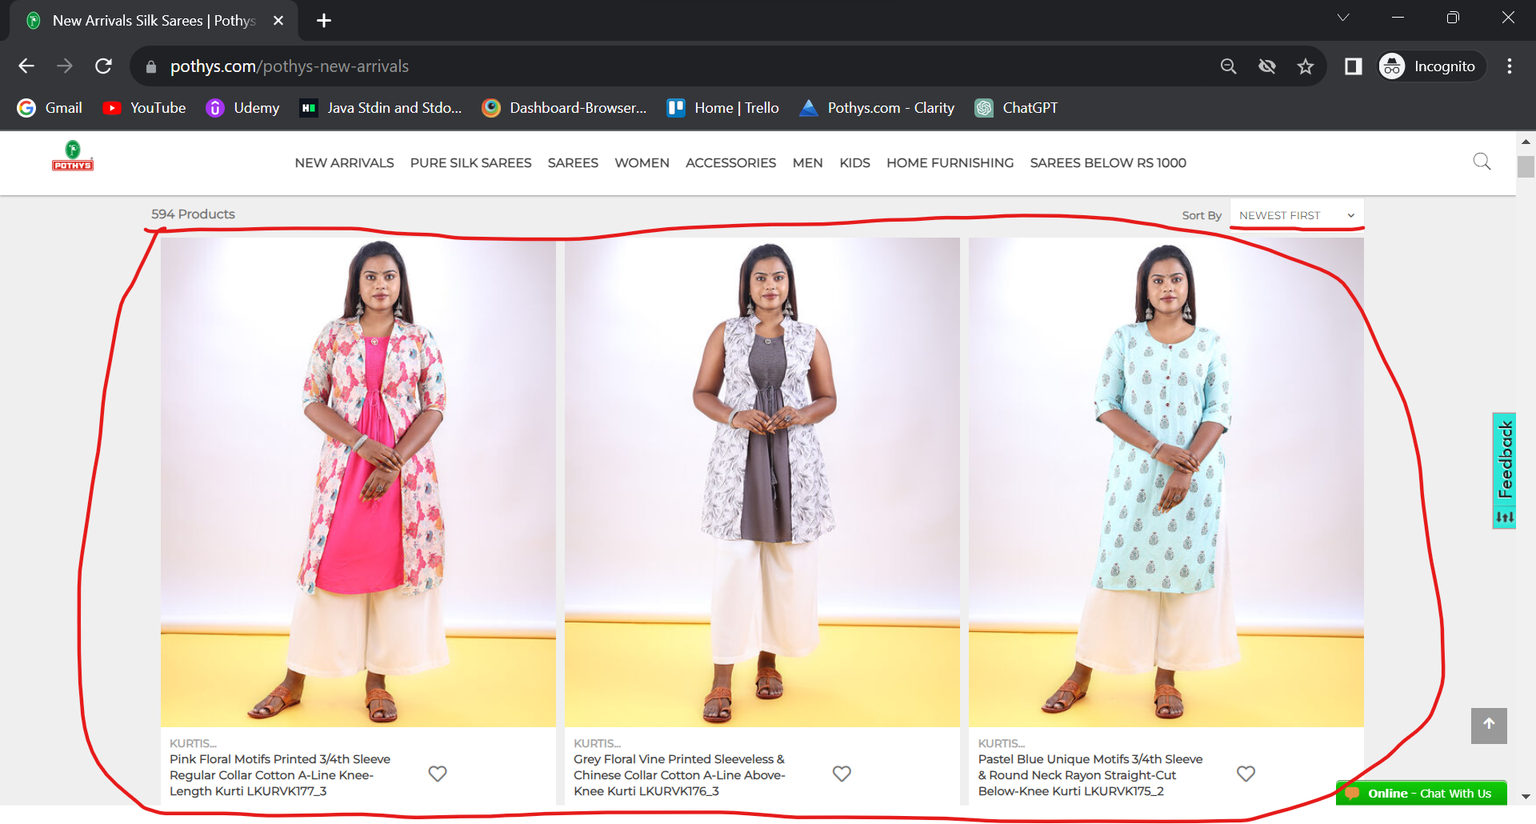

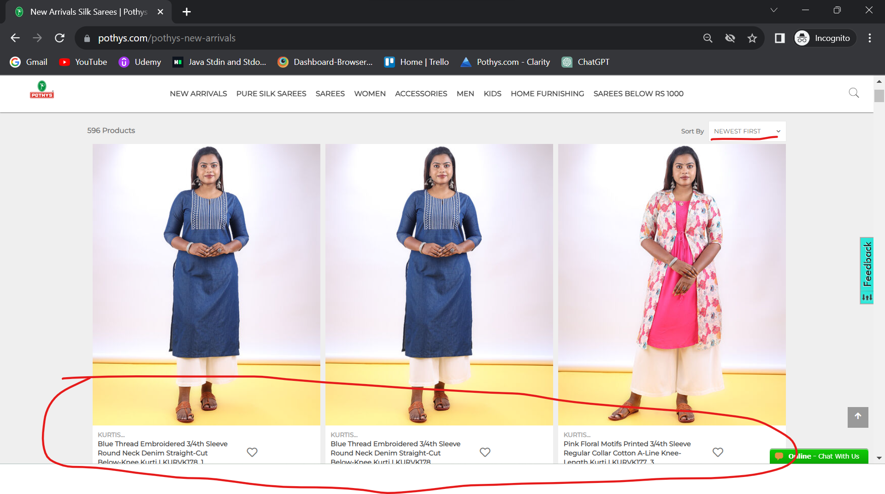

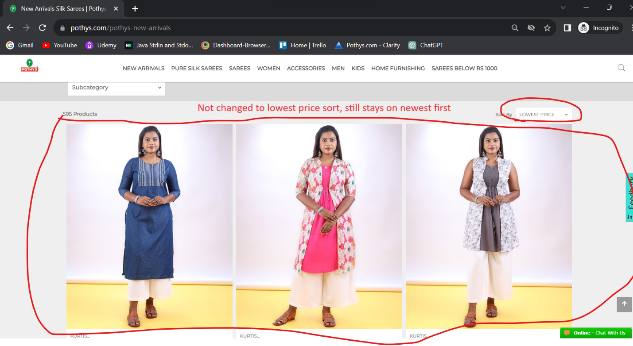

2, selected sort option not highlighting – iPad

